**WEEK - 2 : Advanced SQL (Part 3)**

**Exercise 4: Execute a Stored Procedure**

**SQL Query:**

-- Create Procedure

CREATE PROCEDURE GetAllEmployees

AS

BEGIN

SELECT * FROM Employees;

END;

-- Execute Procedure

EXEC GetAllEmployees;

**Output:**

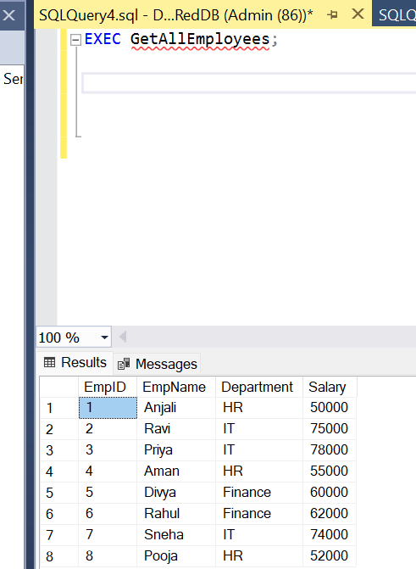

**Exercise 5: Return Data from a Stored Procedure**

**SQL Query:**

-- Create Procedure with Parameter

CREATE PROCEDURE GetEmployeesByMinSalary

@MinSalary INT

AS

BEGIN

SELECT EmpID, EmpName, Department, Salary

FROM Employees

WHERE Salary >= @MinSalary;

END;

-- Execute Procedure

EXEC GetEmployeesByMinSalary @MinSalary = 60000;

**Output:**

